**Python**

**Exercises**

The code must be submitted under your name in GitHub in a repository called Python. Work individually.

Create one file with all your work and name it: cs361python.py or cs 631python.py.

Do not commit code that does not compile. The code that you commit should have been tested. -10 points for each exercise for code that does not compile on the top of your grade.

You will provide a hardcopy with your code to Dr. Scharff on 12/17.

**Exercise 1**

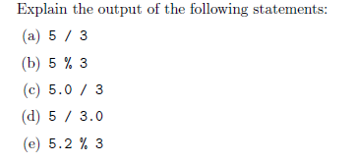

1. The output of the first statement produces that the quotient of when you divide 5 by 3 or 1. 6666666666666667
2. The output produces 2 which is the remainder left over if one were to dived 5 by 3
3. The output of the first statement produces that the quotient of when you divide 5.0 by 3 or 1. 6666666666666667
4. The output of the first statement produces that the quotient of when you divide 5.0 by 3 or 1. 6666666666666667
5. The output produces 2.2 which is the remainder left over if one were to dived 5.2 by 3

**Exercise 2**

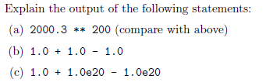

1. This produces an overflow error as the result is a number too big to be compiled OverflowError: (34, 'Numerical result out of range')
2. This is another simple math function in which 1 is subtracted from the sum of 1 plus 1 equaling 1
3. The sum of this equation was 0.

**Exercise 3**

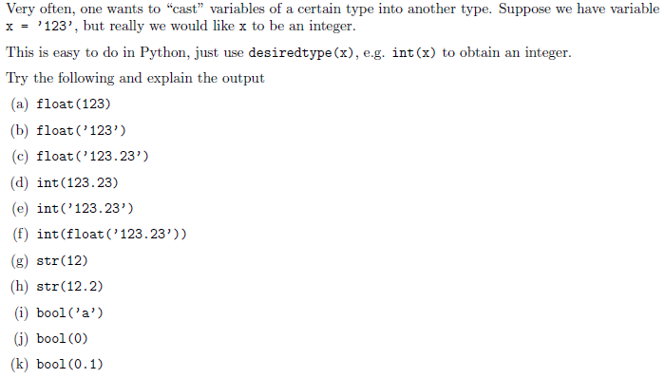

1. 123
2. 123
3. 123.23
4. Unexpected error while parsin
5. invalid literal for int() with base 10
6. 123
7. 12
8. 12.2
9. True
10. False
11. True

**Exercise 4**

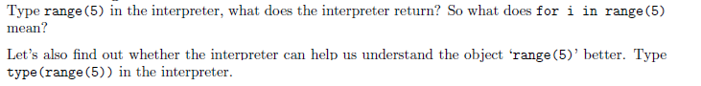

**12345**

**Exercise 5**

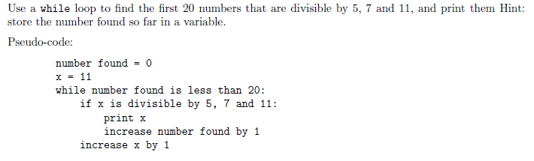

**Exercise 6**

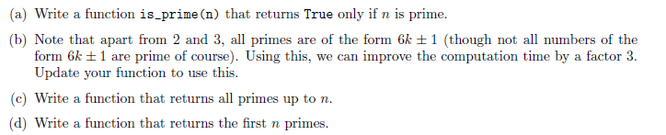

**Exercise 7**

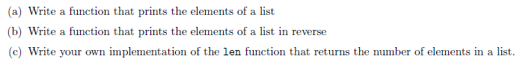

**Exercise 8**



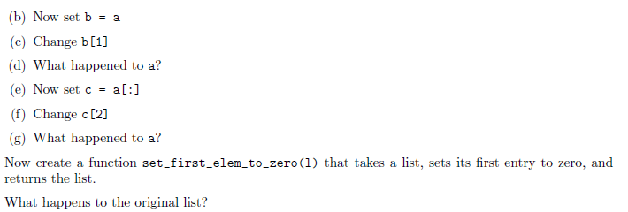

**Exercise 9**



**Exercise 10**

Use mathplotlib

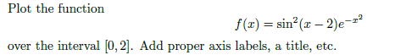

**Exercise 11**



**Exercise 12**

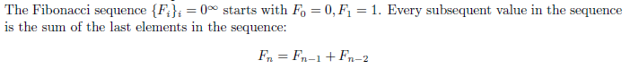

**Exercise 13**

Write a Python program that extracts the email addresses of a file. An email file emails.txt is provided to test your program.

<http://rubular.com/> is a site that can be useful to get familiar with regular expressions.

**References**

Stanford courses on Python <https://web.stanford.edu/~schmit/cme193/exercises.html>